RMI deployement domo (basic):
Following are the details of the RMI deployment demo (basic scheme : not relying on an http server).

1. Create the following directory structure
(client-classes & server-classes are empty):

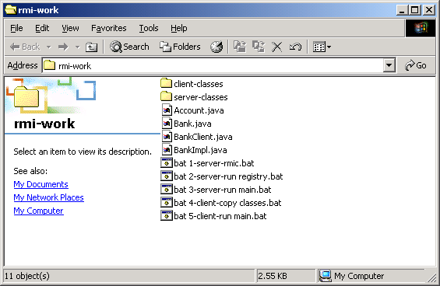

2. The java files should include the java code as listed in the slides

- Account.java
- Bank.java
- BankImmpl.java
- BankClient.java

2. The batch files should include content as follows:

bat1-server-rmic.bat:
rmic -d server-classes/ BankImpl
pause

bat2-run-registry.bat:
cd server-classes
rmiregistry

bat3-server-run-main.bat:
cd server-classes
java BankImpl
pause

bat4-client-copy-classes.bat:
copy server-classes\*.class client-classes\
del client-classes\BankImpl_Skel.class
del client-classes\BankImpl.class
javac -d client-classes BankClient.java
pause

bat5-client-run-main.bat:
cd client-classes
cls
java BankClient
pause

3. Run the batch files at the designated order, and view the result.
Note:
- Please make sure you allow each batch file to execute before attempting to execute the next batch.
- Please make sure you do not close the cmd window running the RMI registry.

